PYTHON PROGRAMMING
CASE STUDY ASSIGNMENT – 5

Case Study 5 Attendance Recovery Computation.
1. Problem Statement
Students receive marks in different subjects during assessments. Comparing these marks manually can make it difficult to identify improvement or decline in performance. This project develops a Python program that compares a student's marks in two assessments, calculates the change in marks for each subject, identifies the subject with the lowest marks in the second assessment, and summarizes the student's overall performance trend.

2. Objectives
- To record a student's marks in two assessments for multiple subjects.
- To calculate the difference between the marks obtained in both assessments for each subject.
- To identify subjects in which the student has improved or declined.
- To identify the subject with the lowest marks in the second assessment.
- To compare the total marks of both assessments and display the overall
performance trend.

3. Assumptions
- At least one subject must be entered.
- Marks for each assessment must be between 0 and 100.
- The same subjects are considered in both assessments.
- The difference in marks is calculated by subtracting Assessment 1 marks from Assessment 2 marks.
- If the total marks in Assessment 2 are greater than Assessment 1, performance is considered improved.
- If both assessment totals are equal, performance is considered unchanged.
3. Assumptions
- At least one subject must be entered.
- Marks for each assessment must be between 0 and 100.
- The same subjects are considered in both assessments.
- The difference in marks is calculated by subtracting Assessment 1 marks from Assessment 2 marks.
- If the total marks in Assessment 2 are greater than Assessment 1, performance is considered improved.
- If both assessment totals are equal, performance is considered unchanged.

5. Flowchart

START
6.pseudo code
If no
If yes
Input subject name and marks for both assessments
Display invalid input message
Is number of subjects greater than 0?

Input number of subjects
STOP
Display results and performance trend
Identify lowest-scoring subject and compare totals
Calculate mark differences and assessment totals
Are marks between 0 and 100?
START
INPUT number _of_ subjects
IF number_ of_ subjects <= 0 THEN
DISPLAY "Enter at least one subject"
ELSE
total1 = 0

total2 = 0
FOR each subject
INPUT subject_ name
INPUT marks1
INPUT marks2
IF marks1 < 0 OR marks1 > 100 OR marks2 < 0 OR marks2 > 100 THEN
DISPLAY "Invalid marks"
STOP
END IF
difference = marks2 - marks1
total1 = total1 + marks1
total2 = total2 + marks2
DISPLAY subject_ name and difference
END FOR
IDENTIFY subject with lowest marks in Assessment 2
DISPLAY total1 and total2
IF total2 > total1 THEN
DISPLAY "Overall performance improved"
ELSE IF total2 < total1 THEN
DISPLAY "Overall performance declined"
ELSE
DISPLAY "Overall performance unchanged"
END IF

7.source code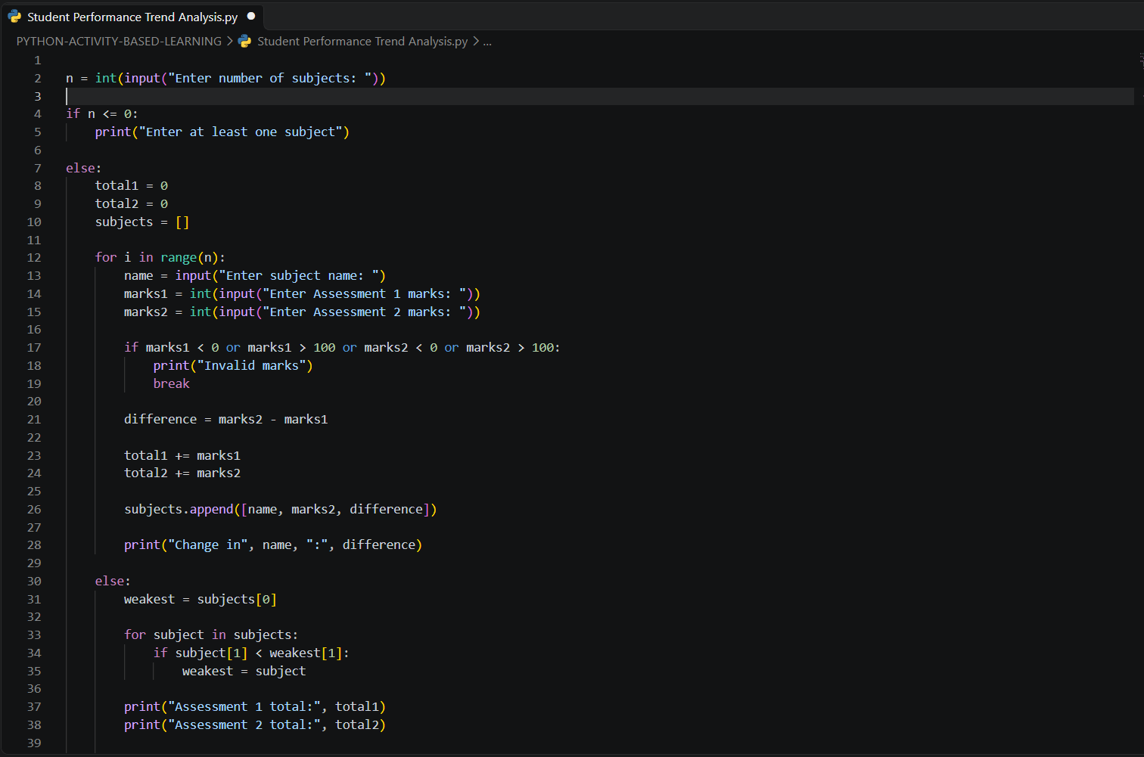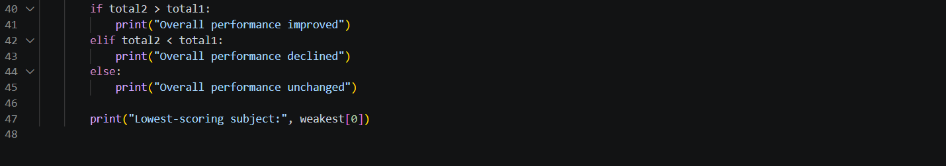

8. Test Cases
Test Case | Input | Expected Output
1 | Maths: 60 → 75, English: 70 → 65 | Maths change: +15, English change: -5, Assessment 1 total: 130, Assessment 2 total: 140, Overall performance improved, Lowest-scoring subject: English
2 | Maths: 80 → 70 | Assessment 1 total: 80, Assessment 2 total: 70, Overall performance declined
3 | Science: 75 → 75 | Assessment 1 total: 75, Assessment 2 total: 75, Overall performance unchanged
4 | Number of subjects: 0 | Enter at least one subject
5 | Maths marks: 110 | Invalid marks
9. Output Screenshots
The output screenshots of the Student Performance Trend Analysis program will be attached below.
Screenshot 1: Program output showing improved performance.
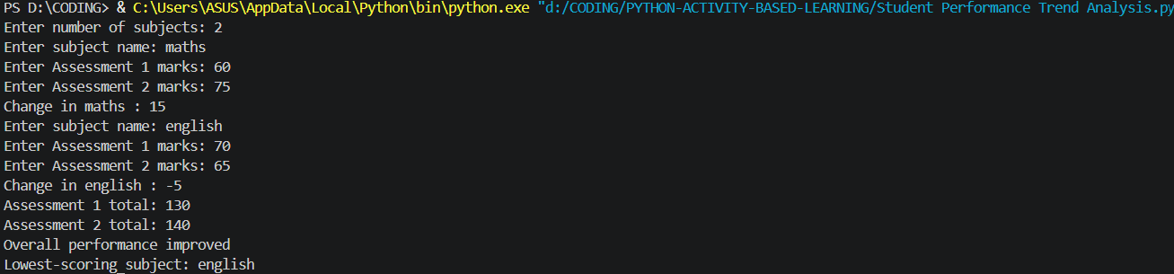
Screenshot 2: Program output showing declined performance.
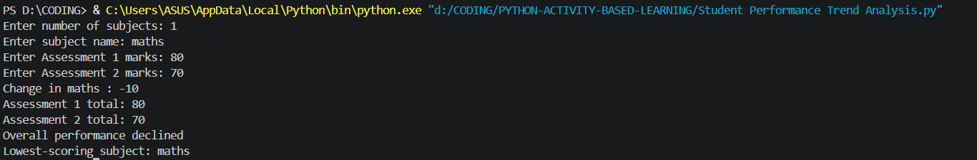
Screenshot 3: Program output showing unchanged performance.
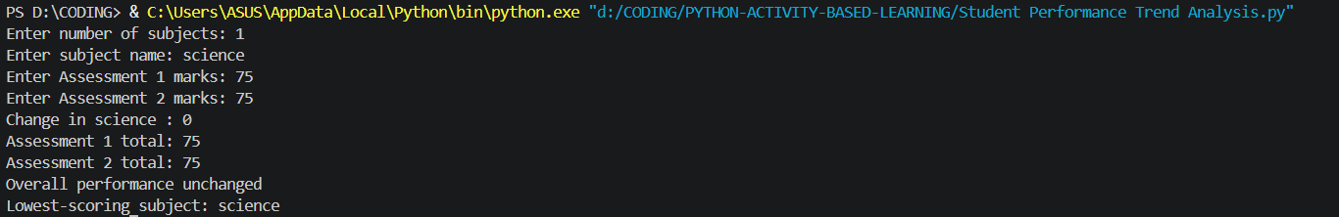
Screenshot 4: Program output showing invalid marks.

10. Conclusion
The Student Performance Trend Analysis program was developed successfully using Python. It accepts students' marks in different subjects for two assessments, calculates the change in marks, compares the overall performance, and identifies the lowest-scoring subject. The program also validates marks to prevent invalid values. This project demonstrates the practical use of loops, conditional statements, lists, arithmetic operations, and input validation in Python. It helps analyze academic performance and identify subjects that may need additional attention.

